Waste recycling plant
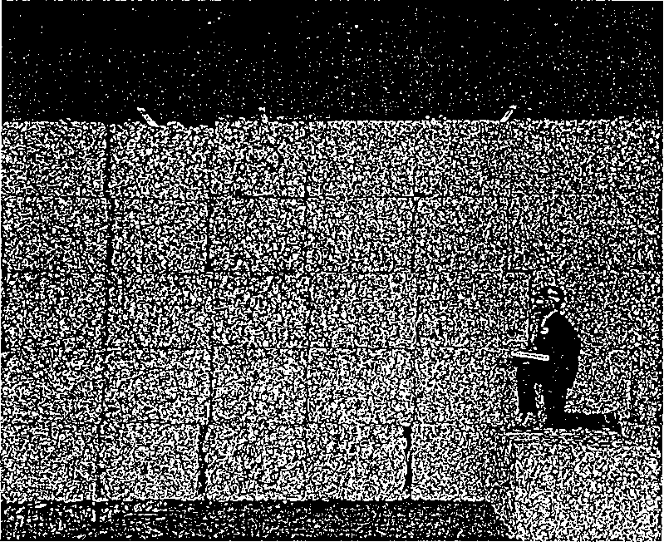

Aluminium can recycling. The bales seen here contain over one million cans.

Tuning-in

Task 1
You are going to read a text on recycling domestic refuse. The main components of refuse are given in the list below. Using your knowledge of engineering, discuss in your group how one of these components could be recovered from refuse and what use could be made of the materials recovered. Your teacher will decide which component each group will discuss.

Ferrous metals Glass Plastics
Paper Organic materials Non-ferrous metals

Task 2
Now report your solutions to the rest of the class. Be prepared to answer questions and defend your ideas.
Task 3
Read the text below to see how the solutions proposed by your class compare with those used in the experimental plant described.

Recycling domestic refuse

The consumer society produces more and more refuse. A number of solutions to this problem have been proposed. In some countries refuse is burnt to generate electric power. In Germany, producers must take back unwanted packaging for recycling. In other countries, householders are asked to separate out refuse so that it can be recycled more easily. This text describes an experimental plant in Holland designed to recycle domestic refuse.
The rubbish collected from households consists of a mixture of organic materials such as kitchen waste, and inorganic materials such as glass and plastic bottles, tin cans, and packaging. The rubbish is first passed through a hammer mill to shred it. The mill consists of rotating steel arms which break up any large items to reduce them to a more manageable size. Any items which may cause damage later in the process are rejected at this stage.
The shredded mixture passes under an electromagnet which removes ferrous metals. Much of this is tin cans. Almost all ferrous metals are recovered in this way.
After that, the residue is carried by conveyor belt to an air classifier. A stream of air is blown through the classifier, which has a zig-zag shape. Low density materials such as plastic, paper, and some organic substances rise to the top of the classifier. Higher density materials such as glass and non-ferrous metals fall to the bottom and are discarded. These could be further separated out using a range of processes. For example, an eddy current mechanism could screen out aluminium waste. Froth flotation techniques could recover glass.
The low density portion is carried to a rotating drum where it is screened. Fine organic materials pass through the screen leaving a mixture which consists mainly of plastic and paper. The organic residue can be used for compost or to make bricks.
The next stage is to separate the plastic from the paper. This was initially a problem as both are similar in density. The solution is to wet the mixture. The paper absorbs water and as a result becomes denser than the plastic.
In the final stage, the wetted mixture is passed through a second air-classifier where the lighter plastic leaves from the top and the denser wet paper from the bottom. The recovered paper could be fed to pulp mills for further recycling.
The remaining plastic is a mixture of thermosets and thermoplastics. It is not easy to separate these out but the mixture can be melted and formed into insulating materials for building.

Reading Transferring information, making notes
Task 4
Using the information in the text, complete the labelling of the flowchart. Add these labels:

plastic and paper mixture air classifier
high density materials rotating drum
shredded mixture ferrous metals
paper wetted mixture
fine organic materials

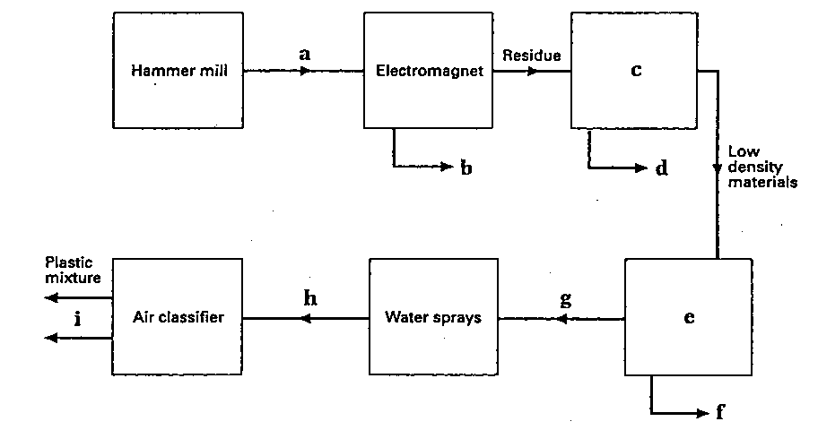

Task 5
Study these notes on the first stage of the recycling process. They contain information on location (Where?), action (What happens?), reason (Why?), and method (How?). Read the text again to complete the notes for the other stages.
Stage 1
Where? hammer mill
What happens? the waste is shredded
Why? to reduce it to a manageable size
How? using rotating steel arms to break up any large items
Stage 2
Where? _______________
What happens? _______________
How? by magnetism
Stage 3
Where? _______________
What happens? high and low density materials are separated
How? by a current of air which carries low density materials to
the top while high density materials fall to the bottom
Stage 4
Where? _______________
What happens? the low density portion is screened
Why? _______________
Stage 5
What happens? _______________
Why? to give the paper and plastic different densities
Stage 6
Where? _______________
What happens? _______________
How? by a current of air which carries low density plastic to the top while wet paper fails to the bottom

Language study Possibility: can and could

Answer these questions about the text.
1 Does this plant screen out aluminium waste?
2 Does it recover glass?
3 Is recovered paper fed to pulp mills?
4 Is recovered plastic melted and formed into insulating blocks?
5 Is organic residue used for compost and bricks?
The answer to questions 1, 2, and 3 is No. The answer to questions 4 and 5 is Yes/Maybe. How do we know? Look at the text.
1 An eddy current mechanism could screen out aluminium waste.
2 Froth flotation techniques could recover glass.
3 The recovered paper could be fed to pulp mills for further recycling.
4 The mixture can be melted and formed into insulating materials for building.
5 The organic residue can be used for compost or to make bricks.
We use could in examples 1, 2, and 3 to show that something is possible but is not in fact done. The reasons why nothing is done in these examples may be expense or lack of demand. We do not know.
We use can in examples 4 and 5 to show that something is possible and may in fact be done.

Task 6
Fill in the gaps in this text with either can or could. Be prepared to justify your answers.
1 With present technology we __________ recycle almost all domestic refuse. But in practice market forces determine what is worth recycling.
2 Successful plants in a number of countries show that refuse, __________ be used as a fuel in power stations.
3 If we recycled most of our refuse, the increasing problem of waste disposal __________ be solved.
4 Sweaters __________ be produced from old plastic bottles. A company in the United States converts the waste plastic into polyester yarn. It takes twenty-five two-litre bottles to make a sweater.
5 At present we __________ not easily separate thermosetting plastics from thermoplastics.

Task 7 Verbs with on and off
Fill in the blanks in these sentences with either on or off. You have studied these verbs in similar contexts.
1 Failure means that expensive development costs must be written _____ with no result.
2 The alarm goes _____ if a window is broken.
3 When the water is hot, the control unit moves _____ to the next stage of the washing programme.
4 Components which rely _____ metal upon metal contact require lubrication.
5 A thermostat causes the gas control valve to shut _____ when the room temperature is correct.
6 Feedback is used to check _____ water level, temperature, and drum speeds.
7 A car thief would set _____ the alarm.
8 If a system is needed urgently, there is no question of knocking _____ at the usual time.
9 Power may come from a small turbine engine, running _____ a clean fuel like natural gas.
10 The accident occurred after the plane took _____ .

